Julius Baer Fixed Income Investment Grade Corporate (USD)
  - a sub-fund of Premium Selection UCITS Class Ah acc EUR
  - As of September 2022

Fund overview
Objective
The fund aims to generate income and capital appreciation by primarily investing in corporate bonds that are predominantly denominated in EUR and have a credit rating of AAA to BBB-. It seeks excess return from exposure to a broad range of financial and corporate bonds in developed markets.
Since 20XX

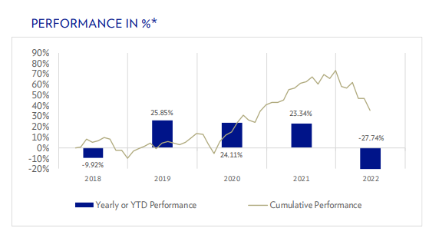

Return
In % | Ytd | 1m | 3m | 6m | 1y | 3y p.a. | 5y p.a. | Since launch
The fund
Benchmark††
EUR | 2018 | 2019 | 2020 | 2021 | 2022
The fund
Benchmark††

Statistics
Volatility (%)
Number of holdings
Dividend yield


Fund Managers
Since 20XX
Since 20XX

Key facts
NAV per share
Total fund size | USD M

ISIN
Bloomberg ticker

Investment manager
Fund management company
Legal structure
Domicile
Share class launch date
Fund launch date
Base Currency
Currency hedging
Dealing frequency
Benchmark

Total Expense Ratio

SFDR classification

Investment thesis
- Bayer AG (Bayer), based in Leverkusen, Germancy, manufactures products that include cardiovascular, oncology, haematology and ophthalmology drugs, overt-the-counter (OTC) medications, animal health products and
crop-protection products. In September 2016, Bayer announced the acquisition of US-based Monsanto Co. (Monsanto), which will make Bayer the world’s largest seed and agricultural chemical company.
- Even though Bayer’s leverage will increase owing to the Monsanto acquisition, we expect strong performance of its Pharmaceutical segment in the short term, which combined with geographyical diversification and strong access to capital markets, should outweigh any negatives.

Key risks
- The company-specific risk is influenced by two factors: the environment specific to that company, and the quality of its management. The most effective way to reduce company-specific risks is to diversify across a range of bonds — in other words, to seek portfolio diversification.
- Interest rate and currency risks have to be considered before investing in this bond. The price of the bond will most likely suffer if the general yield level of the US dollar yield curve shifts up or company specific risk perception increases.

Characteristics
Effective duration(yrs)
Benchmark duration(yrs)
Current yield(%)
Estimated yield to maturity(%)
Average coupon (%)
Effective maturity(yrs)

Allocation by currency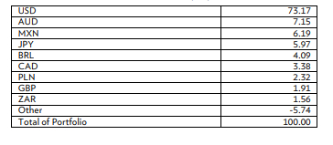
Allocation by industry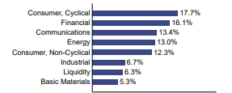
Allocation by region
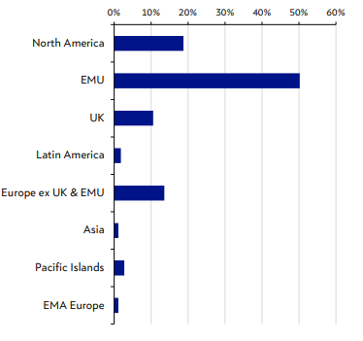
Allocation by duration
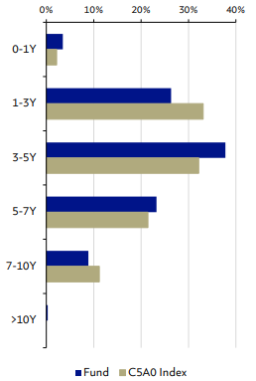
Allocation by ratings
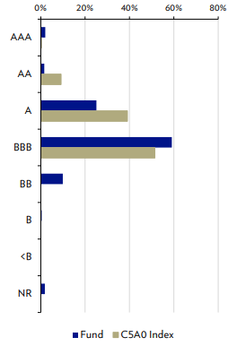
Top ten holdings
Security | Currency | Holdings (%)
Total

Glossary

Important legal information

This publication has been produced by Bank Julius Baer & Co. Ltd., Zurich, which is authorised and regulated by the Swiss Financial Market Supervisory Authority (FINMA). This publication series is issued regularly. Information on financial instruments and issuers is updated irregularly or in response to important events.

Disclosures
The Julius Baer Group Ltd. and its affiliated companies (the “Group”) may enter into transactions for their own account or for the account of other investors that are related to the bonds that may be mentioned in this publication (issuers BNP Paribas, Citigroup, Credit Suisse, Deutsche Bank, UBS). Furthermore, the Group may have or have had a (co-lead) role in the issuance of the Bonds or other debt instruments of the relevant companies. Accordingly, conflicts of interest may arise between the Group and the client. If so,
the Group strives to provide fair and equitable treatment of such conflicts.
No further specific disclosures.

Source- Past performance is not an indicator of future performance.
As of XX date
As of xx

